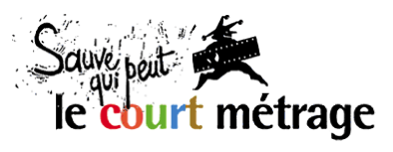 | presents | EURO CONNECTION VIII  09-10 February 2016 – Clermont-Ferrand

Euro Connection is the European Short Film Co-production Forum taking place each year at the Clermont-Ferrand Short Film Market. This business platform aims at fostering partnerships between European production companies, funders and broadcasters for short film projects.

The next edition of Euro Connection will take place on Tuesday 9 and Wednesday 10 February 2016 during the Clermont-Ferrand Short Film Market. Euro Connection is organised by Sauve Qui Peut le Court Métrage (Clermont-Ferrand) in association with the Creative Europe MEDIA Desk France and the Centre National du Cinéma et de l’Image Animée, with the support of the Creative Europe MEDIA sub-programme and the PROCIREP.

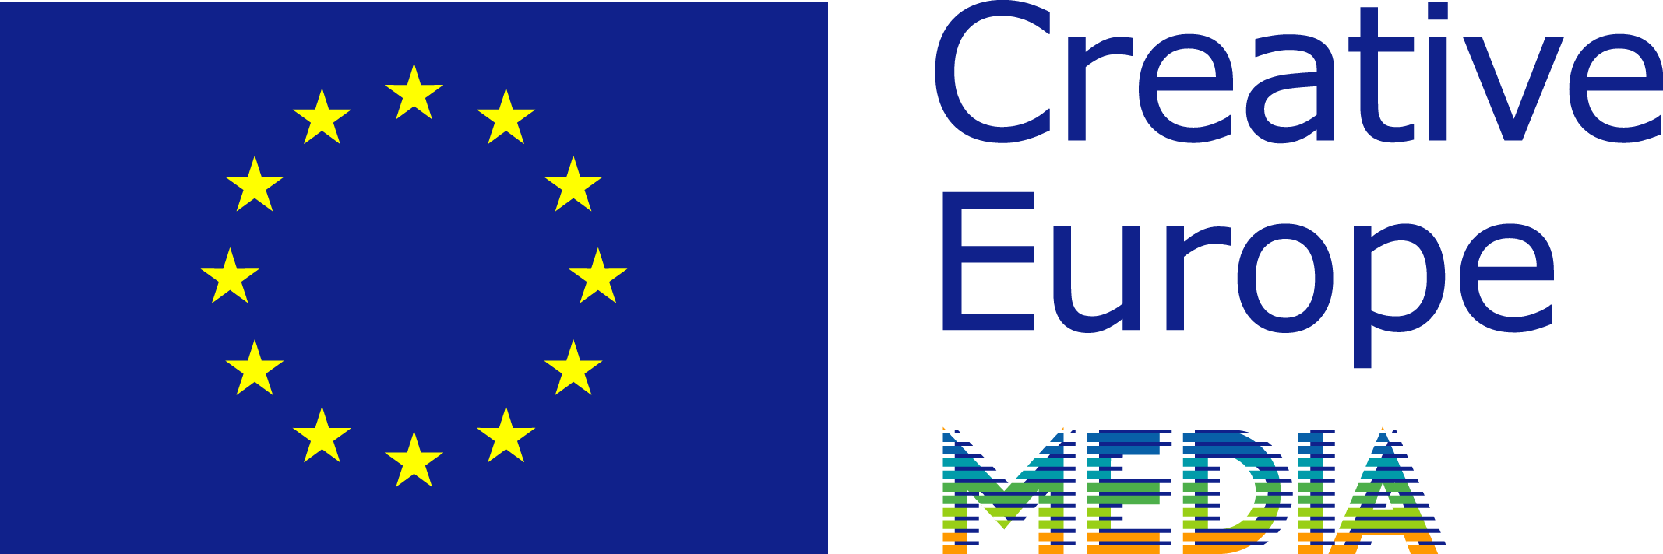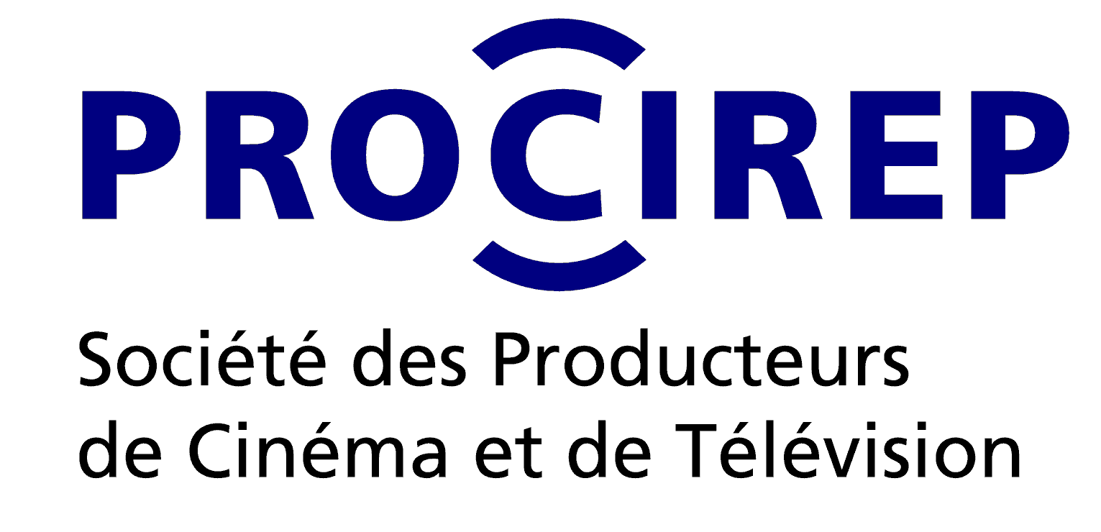

CALL FOR PROJECTS 2016

What is Euro Connection?
Each year 16 short film projects are selected across Europe to participate in Euro Connection, with the help of a network of national correspondents in each of the associated countries. The producers of the selected projects receive an invitation that includes a travel grant, hotel accommodation, meals and a free accreditation to the Short Film Market in Clermont-Ferrand.

The selected projects are highlighted in the Book of Projects and Producers, with details for each project and a profile of their authors and producers. Its publication (mid-January) is announced to European producers, broadcasters, fund representatives and financial backers registered to Clermont-Ferrand, who are invited to secure attendance to the pitching sessions during Euro Connection.

The event revolves around:
- Pitch training workshop (Monday 8 February 2016).
- Pitching sessions (Tuesday 9 February 2016).
- Facilitated networking for producers and participants.
- One-on-one business meetings (Wednesday 10 February).

150 industry delegates take part in Euro Connection each year.
So far, 58 films were completed, including 27 European co-productions as a direct result from the first six editions of Euro Connection.

How does it work?
Producers officially located in one of the associated countries must send their application by email to the national correspondent in their country no later than October 23, 2015.

In each country the national correspondent sets up an expert committee who will review the applications and nominate 1 finalist project. The expert committees will especially pay attention to the artistic value of the projects. Each national correspondent will inform the applicants of the results of the nomination of the finalist project. The producers of the finalist projects will be expected to send an English version of their application, including script, promptly after the nominations (for producers who apply to their correspondents with an application in another language than English).

A European jury will then meet and elect 15 selected projects from all the finalist projects. The jury will include 5 industry professionals from different nationalities. All finalist participants will be informed of the list of selected projects for Euro Connection by the end of November 2015.

For Baltic countries (Estonia, Latvia, Lithuania), the winning project of the Baltic Pitching Forum (Vilnius, October 9 & 10, 2015) will be selected for Euro Connection, as a result from the partnership between these two events.

Who can apply, with what kind of projects?
May apply producers whose company is officially located in one of the countries associated to the 2016 edition: Austria, Belgium (French-speaking), Bulgaria, Croatia, Cyprus, Czech Republic, Denmark, Finland, France, Germany, Greece, Hungary, Ireland, Italy, Luxembourg, Netherlands & Flanders, Poland, Portugal, Romania, Slovenia, Spain, Sweden, United Kingdom.

Only projects respecting the following eligibility criteria will be considered:
- The project is a short film (animation, fiction, creative documentary).
- The duration does not exceed 40 minutes.
- The project must have partial funding granted by an external source (third party organisation).
- The producer is open to international co-production (project suitable or intended for co-production)
- Shooting or production shall start no earlier than May 2016.

Any producer applying with a project formally commits to attend Euro Connection in person in Clermont-Ferrand in case of selection.

Sending the application
Producers must send their application by email to the national correspondent in their respective country (see table below) no later than October 23, 2015. Applications shall be sent as 1 single pdf file containing the entry form below carefully filled out, with all other additional documents required. Incomplete applications will not be considered. The correspondents are at the disposal of applicants for any query regarding application with a project.

Invitation for producers
The producer of each selected project will be invited to Euro Connection (limited to one person per production company) to pitch their project. Invitation covers:
- A 160 € travel grant
- 4 hotel nights and meals (Arrival Sunday 7 Feb. – Departure Thursday 11 Feb. 2016)
- Full accreditation to the Short Film Market in Clermont-Ferrand.

The authors/directors of the projects will be welcome (in shared hotel room with producer). They will also be granted a free Market accreditation.

The producers of the remaining finalist projects, outside the final selection, will also be invited to attend Euro Connection (4 hotel nights + meals + accreditation, for 1 person per project) for networking with attending industry delegates.

Contact
Euro Connection, Short Film Market Clermont-Ferrand – www.clermont-filmfest.com
Laurent Crouzeix: +33.(0)4 73 14 73 12
Julie Rousson: +33.(0)4 73 14 22 / euroconnection@clermont-filmfest.com

Entry form – Euro Connection 2016

Short film project
Original title: ……………………………………………………………………………………...……
English (or international) title: ………………………………………………………………………
Directed by: …………………………………………………………………………………………...
Script by: …………………………………………………………………………………………….....
Production company: ………………………………………… Country:…………………........
Producer’s name: …………………………………………………………………………………….
Short synopsis / description (500 signs max.):

Key contact details
Producer’s e-mail:………………………………... Mobile phone: …………………………………..
Director’s e-mail:………………………………….. Mobile phone: ……………………………………
Production company’s address:........................................................................................................
Postcode: ………………… City: …………………………………………………………
Phone: ………………………………….. Website:……………………………………….......

Tech specs
Genre:  fiction  animation  creative documentary
Planned shooting format: ……………………………………………
Estimated running time: ………………….. minutes
Planned dates of shooting: ........................................................................

Budget and financing
Total estimated budget (in euros): ……………………………………… €
Secured funding (at time of application): ……..…..………............... € ( i.e. .… % of budget)
 I confirm that project has secured partial funding from an external source.
Amount of funding granted: ……..…..………............... €
Origin of funding:
❒ script development grant  broadcaster
❒ state production fund  prize/award/foundation money
❒ local/regional/city production fund  other (specify:…………………...................)
Funding granted by (name of organization):...............................
Confirmed on (date): ..................................

Director’s short bio (750 signs max.)

Production company profile (500 signs max.)

Producer’s short bio (750 signs max.)

Additional following documents are requested

- Complete script;
- The director's letter of intent;
- Proof of funding granted by third party organisation (confirmation notice, letter, etc.);
- CV and photo of director;
- CV and photo of producer;
- Filmography and logo of production company
- Whenever possible, video link to previous film (or clips) by same director;

 I commit to attend Euro Connection (Feb. 7-11, 2016) in Clermont-Ferrand if my project is selected.
Full name :
Date :
Signature :

List and contacts of national correspondents in countries associated to the 2016 edition

The entry form carefully filled out must be sent by email to the national correspondent in your country (see table below) in 1 single pdf file together with the additional documents required. Thank you!

The documents contained in the application are intended for use of the expert committees.
Please note that the information contained in your form and application will be published and made available online to facilitate networking between production companies in case of selection. Text and material received may be edited prior to publication to adapt to the Book of Projects’ format.

AUSTRIA |  | IRELAND
VIS - Vienna Independent Shorts  Marija Milovanovic | +43 650 53 41 800  marija.milovanovic@viennashorts.com | IndieCork Film Festival  Una Feely | +353 868 096 305  una@indiecork.com
BELGIUM (Wallonia-Brussels Federation) |  | ITALY
Wallonie Bruxelles Images  Geneviève Kinet | +32 2 223 23 04  genevieve.kinet@wbimages.be | Centro Nazionale del Cortometraggio  Jacopo Chessa, Eugènie Bottereau | +39 011 5361468  promozione@centrodelcorto.it
BULGARIA |  | LUXEMBOURG
Creative Europe Desk Bulgaria  Kamen Balkanski | +359 2 988 32 24  info@mediadesk.bg | Film Fund Luxembourg  Norbert Laporte | +352 247 821 73  Norbert.Laporte@filmfund.etat.lu
CROATIA |  | NETHERLANDS & Flemish Community
Creative Europe Desk Croatia – MEDIA office  Martina Petrovic | +385 146 554 34  martina.petrovic@mediadesk.hr | Go Short, Leuven ISFF  Anne van der Veer | +31 246 636 789  info@goshort.nl
CYPRUS |  | POLAND
ISFFC – International Short Film Festival of Cyprus  Alexia Roider  Kimonas Mylonas | +357 994 317 78  aroider@gmail.com  +357 995 724 68  mkimonas@hotmail.com | Krakow Film Foundation  Barbara Orlicz | +48 12 294 69 45  barbara.orlicz@kff.com.pl
CZECH REPUBLIC |  | PORTUGAL
Czech Film Center  Marketa Santrochova | +420 221 105 322  marketa@filmcenter.cz | Festival Curtas Vila do Conde  Nuno Rodrigues  Festival IndieLisboa  Miguel Valverde | +351 252 638 027  nuno@curtas.pt  +351 213 158 399  miguel.valverde@indielisboa.com
DENMARK |  | ROMANIA
Creative Europe Desk Denmark  Ene Katrine Rasmussen | +45 20470290  ener@dfi.dk | Romanian Film Promotion  Ramona Sarbu | Tel/Fax: +40 213 266 480  ramona@tiff.ro
FINLAND |  | SLOVENIA
Tampere Short Film Festival  Juhani Alanen | +358 40 5833211  juhani.alanen@tff.fi | Animateka International Animated Film Festival  Igor Prassel | +386 318 364 31  igor.prassel@animateka.si
FRANCE |  | SPAIN
Sauve Qui Peut le Court Métrage  Laurent Crouzeix | +33 473 14 73 12  l.crouzeix@clermont-filmfest.com | Madrid en corto  Ismael Martín | +34 915 121 060  ismael@madridencorto.es
GERMANY |  | SWEDEN
AG Kurzfilm e.V.  German Short Film Association  Maria Völzer | +49 351 4045575  voelzer@ag-kurzfilm.de | Swedish Film Institute  Andreas Fock | +46 8 665 12 15  andreas.fock@sfi.se
GREECE |  | UNITED KINGDOM
Greek Film Centre  Stavroula Geronimaki | +30 210 367 85 30 stavroula.geronimaki@gfc.gr | British Council  Will Massa | +44 207 389 48 84  will.massa@britishcouncil.org
HUNGARY |  | BALTIC COUNTRIES (winner Best Pitch)
Daazo  Zsuzsanna Brasher | +36 209 457 878  zsuzsanna.brasher@daazo.com | Baltic Pitching Forum

Correspondents who’ll receive 10 applications or more in their country can nominate up to 2 finalist projects.
No minimum amount is required, yet the partial funding secured must come from a third party organisation (i.e script development grant, production fund, state or local government support, investment from a broadcaster, prize money from a foundation or contest, etc.) In-kind contributions or investment share from the original production company are not considered valid as acquired partial funding in the respect of this selection process.

